**WEEK-7**

**REACT**

**12. ReactJS-HOL**

**Create a React Application named “ticketbookingapp” where the guest user can browse the page where the flight details are displayed whereas the logged in user only can book tickets.**

**CODE:**

**Step 1: Create React App**

npx create-react-app ticketbookingapp

cd ticketbookingapp

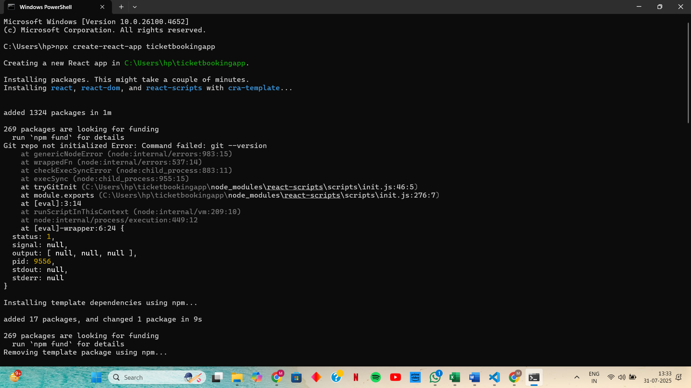

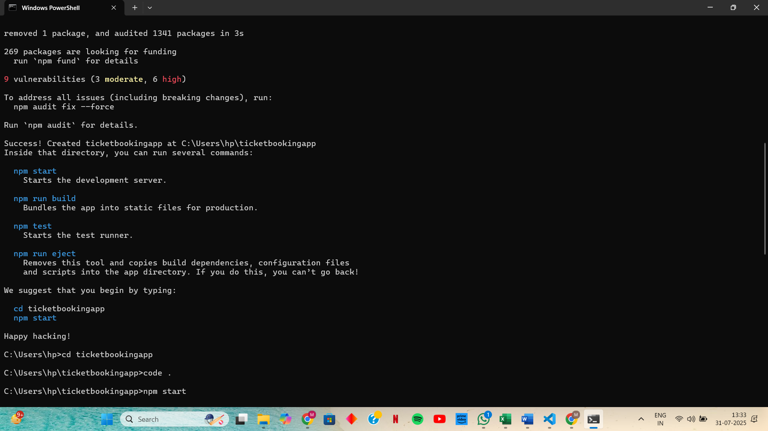

**Step 2: Update App.js in src**

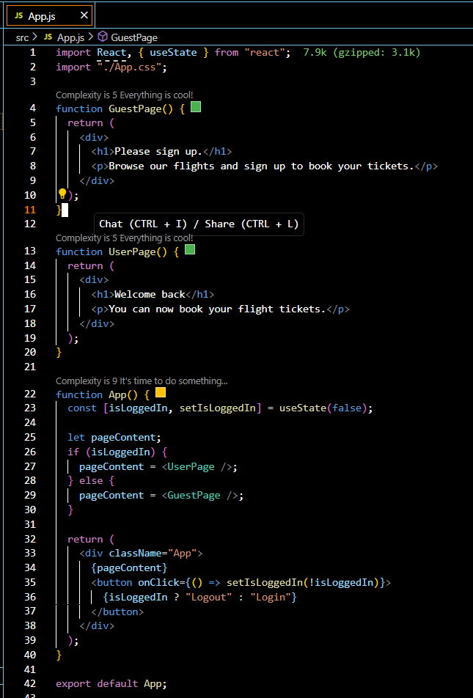

**OUTPUT:**

